Task 2 : HOW TO CONFIGURE GIT WITH YOUR USERNAME TO TRACK THE CHANGES YOU MAKE

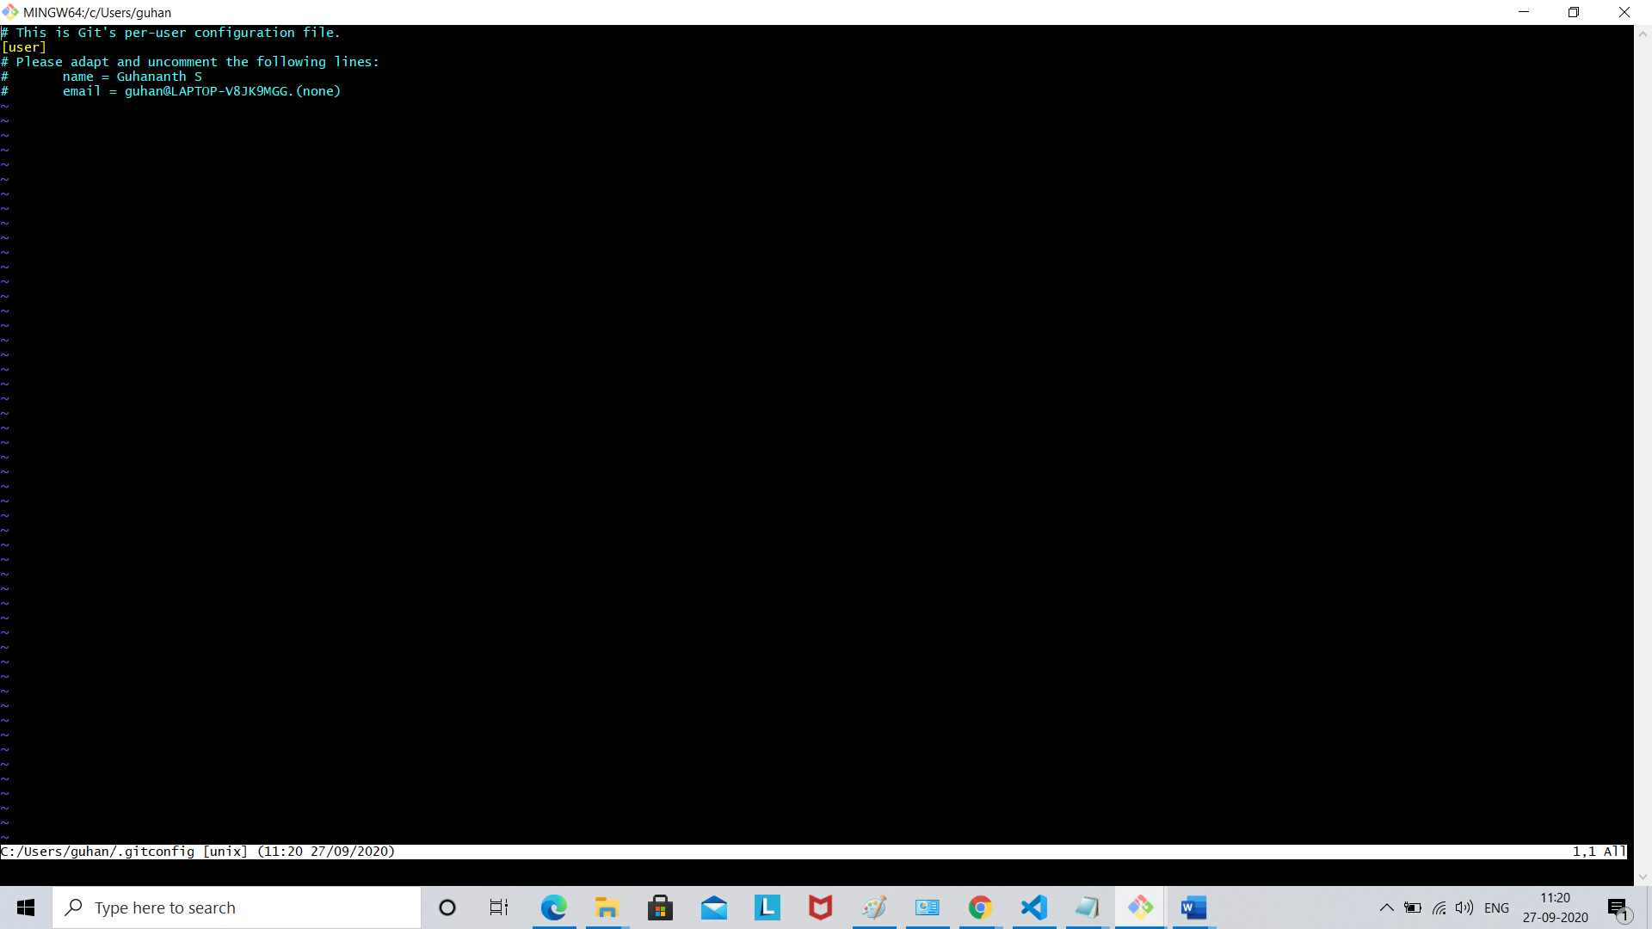

To save file

